Stem cells reprogrammed using chemicals alone
Patient-specific cells could be made without genetic manipulation.
- David Cyranoski
18 July 2013
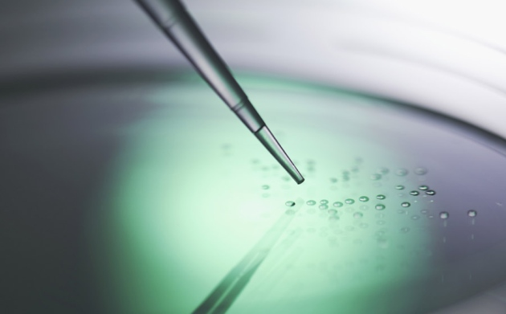
Turning human cells into stem cells without changing their genes could lead to therapies that do not carry a risk of generating mutations.
ANDREW BROOKES/CORBIS

Article tools
Scientists have demonstrated a new way to reprogram adult tissue to become cells as versatile as embryonic stem cells — without the addition of extra genes that could increase the risk of dangerous mutations or cancer.
Researchers have been striving to achieve this since 2006, when the creation of so-called induced pluripotent (iPS) cells was first reported. Previously, they had managed to reduce the number of genes needed using small-molecule chemical compounds, but those attempts always required at least one gene, Oct4^{2, 3}.
Now, writing in Science, researchers report success in creating iPS cells using chemical compounds only — what they call CiPS cells¹.
Hongkui Deng, a stem-cell biologist at Peking University in Beijing, and his team screened 10,000 small molecules to find chemical substitutes for the gene. Whereas other groups looked for compounds that would directly stand in for Oct4, Deng's team took an indirect approach: searching for small-molecule compounds that could reprogram the cells in the presence of all the usual genes except Oct4.
Then came the most difficult part. When the group teamed theOct4 replacements with replacements for the other three genes, the adult cells did not become pluripotent, or able to turn into any cell type, says Deng.

Fine-tuning
The researchers tinkered with the combinations of chemicals for more than a year, until they finally found one that produced some cells that were in an early stage of reprogramming. But the cells still lacked the hallmark genes indicating pluripotency. By adding DZNep, a compound known to catalyse late reprogramming stages, they finally got fully reprogrammed cells, but in only very small numbers. One further chemical increased efficiency by 40 times. Finally, using a cocktail of seven compounds, the group was able to get 0.2% of cells to convert — results comparable to those from standard iPS production techniques.
The team proved that the cells were pluripotent by introducing them into developing mouse embryos. In the resulting animals, the CiPS cells had contributed to all major cell types, including liver, heart, brain, skin and muscle.
“People have always wondered whether all factors can be replaced by small molecules. The paper shows they can,” says Rudolf Jaenisch, a cell biologist at the Whitehead Institute for Biomedical Research in Cambridge, Massachusetts, who was among the first researchers to produce iPS cells. Studies of CiPS cells could give insight into the mechanisms of reprogramming, says Jaenisch.

The frog's secret
The achievement could even help regenerative biologists to work out how amphibians grow new limbs. Deng’s group found that one gene indicative of pluripotency, Sall4, was expressed much earlier in the CiPS-cell reprogramming process than in iPS-cell reprogramming. The same Sall4involvement is seen in frogs that regenerate a lost a limb⁴: before the regeneration, cells in the limb de-differentiate, a process akin to reprogramming, and Sall4 is active early in that process.
The discovery “provides an important framework to decipher the signalling pathways leading to Sall4expression” in regulating limb regeneration, says Anton Neff, who studies organ regeneration at Indiana University in Bloomington.
Sheng Ding, a reprogramming researcher at the Gladstone Institutes in San Francisco, California, says that the study marks “significant progress” in the field, but notes that chemical reprogramming is unlikely to be used widely until the team can show that it can work for human cells, not just mouse ones. Other strategies, including one that uses RNA, can complete reprogramming with less risk of disturbing the genes than the original iPS-generation method, and are already in use in humans. Indeed, clinical trials with iPS cells derived through such means are already being planned.
Deng has made some progress towards using his method in human cells, but it will require tweaks. ”Maybe some additional small molecules are needed,” he says.
If it the technique is found to be safe and effective in humans, it could be useful for the clinic. It does not risk causing mutations, and the compounds themselves seem to be safe — four of them are in fact already in clinical use. The small molecules can easily pass through cell membranes, so they can be washed away after they have initiated the reprogramming.

